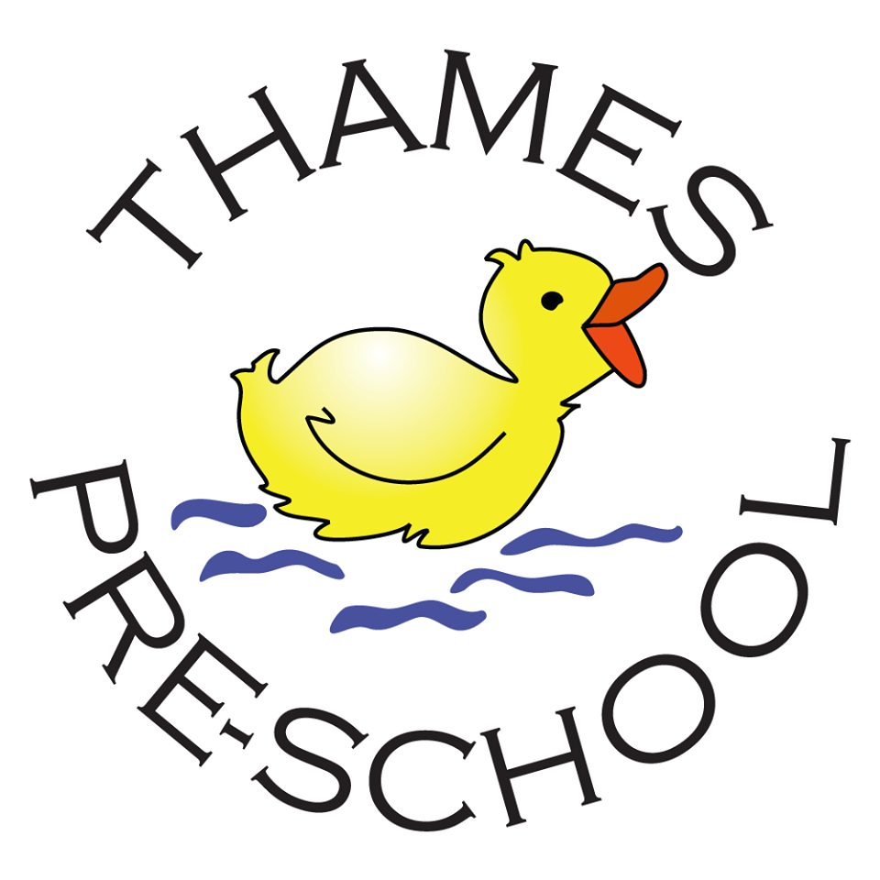

Thames Term Dates 2019/20

Term 1
Mon 2nd September 2019 – Fri 18th October 2019
Term 2
Mon 4th November 2019 – Fri 20th December 2019
Term 3
Mon 6th January 2020 – Fri 14th February 2020
Term 4
Mon 24th February 2020 – Fri 3rd April 2020
Term 5
Mon 20th April 2020 – Fri 22nd May 2020 (Bank Holiday: Fri 8th May)
Term 6
Mon 1st June 2020 – Fri 17th July 2020
​

