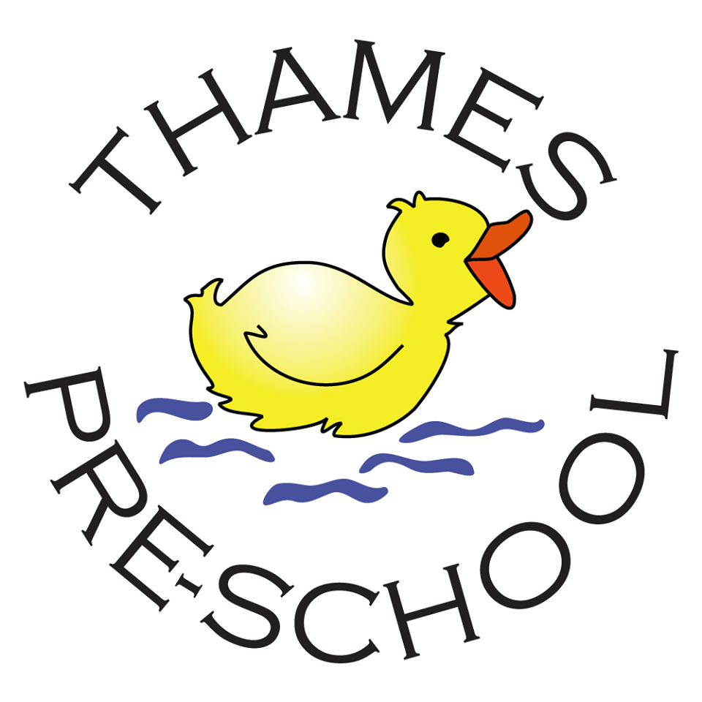
COVID-19 Operating Policy & Procedures

Contents

- Background
- Social Distancing

- Thames Pre-school Covid Policy
3.1 Attendance
3.2 Sessions
3.3 Groupings
3.4 Daily routine
3.5 Parent emergency contact details & test and trace
3.6 Hand washing and personal hygiene
3.7 Environment and resources
3.8 Cleaning
3.9 COVID-19 emergency boxes
3.10 Staff breaks and office use
3.11 Hot lunches
3.12EYFS

- Procedure for managing a child displaying symptoms of COVID-19
- Procedure in Case of a Positive COVID-19 Result
- Process for a child showing symptoms of COVID-19

- Addendum to Child Protection Policy

1. Background

Following the government advice that Early Years settings can re-open for all children from 1st June 2020, this policy details how Thames Pre-school will operate, including the procedures which will be in place to enable us to best maintain the safety, health and well-being of our staff, children and their families.

This policy takes its direction from the following documents which were issued in May 2020, if this government guidance is updated, then this policy will be reviewed and adjusted accordingly.

All of Thames Pre-school policies still apply although this COVID-19 policy will take precedence at the current time.

https://www.gov.uk/government/collections/coronavirus-covid-19-guidance-for-schools-and-other-educational-settings
https://www.gov.uk/government/publications/preparing-for-the-wider-opening-of-schools-from-1-june
https://www.gov.uk/government/publications/coronavirus-covid-19-implementing-protective-measures-in-education-and-childcare-settings/coronavirus-covid-19-implementing-protective-measures-in-education-and-childcare-settings
https://www.gov.uk/government/publications/covid-19-decontamination-in-non-healthcare-settings/covid-19-decontamination-in-non-healthcare-settings

2. Social Distancing in Early Years

The government guidance has advised that where a 2m distance from young children cannot be maintained, that the following ‘system of controls’ should be in place;

- Minimise contact with individuals who are unwell by ensuring that those who have coronavirus (COVID-19) symptoms, or who have someone in their household who does, do not attend settings,
- clean hands thoroughly, more often than usual,
- ensure good respiratory hygiene by promoting the ‘catch it, bin it, kill it’ approach,
- introduce enhanced cleaning, including cleaning frequently touched surfaces often using standard products, such as detergents and bleach,
- minimise contact between groups where possible,
- where necessary, wear appropriate personal protective equipment (PPE),
- engage with the NHS Test and Trace process,
- manage confirmed cases of coronavirus (COVID-19) amongst the setting community,
- contain any outbreak by following local health protection team advice,
- notify Ofsted
1 to 4 must be in place in all settings, all the time. 5 must be properly considered, and settings must put in place measures that suit their particular circumstances. 6 applies in all specific circumstances. 7 to 10 must be followed in every case where they are relevant.

3. Thames Pre-school COVID Policy

3.1 Attendance – who can/should attend pre-school

- All children who normally access childcare are strongly encouraged to attend so that they can gain the learning and well-being benefits of early education.
- The pre-school will not accept children who attend any other settings (e.g other pre-schools or childminders). For children who currently attend more than one setting, the parent will be asked to choose which setting their child will continue to attend.
- Thames Pre-school reserves the right to change the offer of sessions to any children in the case of changing government or public health advice, or if staffing levels are affected.
- Families attending Thames are expected to be following the current government guidance around social distancing. If a family are known not to be following the guidance, we may refuse a child’s attendance at pre-school for a period of 14 days.

In the case of changes to shielding advice and/or a local or national lockdown;

- If shielding is extended or re-applied to children or families who normally attend Thames, we will contact the families directly to discuss how this affects their child attending pre-school, and follow any updated government guidelines.
- If a local or national lock down is applied, we would expect to be able to close for the majority of children.
- We would expect to remain open to the children whose parents are key workers, to enable these parents to continue to go to work.
- We would expect to be able to continue to offer sessions for children deemed ‘vulnerable’.
- The number of children we can remain open for will be dependant on staff availability and space in each session.
- We have resources prepared to provide home learning opportunities for children not attending, and will keep in touch with all families via Tapestry.

3.2 Sessions and groups

- We will be operating as a ‘full pre-school bubble’ to allow us to provide as much normality as we can, and support children’s developmental needs.
- Our sessions will be as per normal operation (see our website for details) and will include our breakfast and after school clubs.
- Children will not be separated into small groups and can mix freely.
- Children will not be expected to social distance from each other or staff.
- Staff will maintain social distancing from each other as far as possible during sessions.
- Staff will always maintain social distancing from parents and any other adults.
- No additional adults will be allowed in the building other than Thames Pre-school staff during each session unless they are for essential medical or educational purposes.
- Contact details for all adults entering the setting will be requested and recorded on arrival for the purposes of Test and Trace, if required.

3.3 Daily routine

Travelling to and from pre-school

- Children should be accompanied by 1 parent/carer only, this will reduce the number of adults congregating at pre-school.
- Parents, children and staff should follow social distancing rules while travelling to pre-school.
- Walking or cycling to pre-school is advised, but if public transport is used face masks or other precautions should be used, where necessary.

Drop off

- There will be signs displayed at the entrance to the setting reminding parents of the current social distancing guidelines.
- Parents should keep their children next to them and stand 2m apart from other families/households.
- We are not able to allow parents into the building.
- If a child is reluctant to separate from a parent, the parent can settle their child in the garden area, and will be supported by staff.
- There will be a member of staff at the entrance to greet and help the children to come in.
- Only one family at a time should use the ramp to enter/exit.
- Staff will sign their child in at the main door.
- Parents will be asked to remove their child’s coat and take it home with them. The child will be asked to hang their bag on their peg.
- Children must not bring any items in from home, such as teddies, dolls or show-and-tell items.
  - Any personal items such as nappies, sunscreen, spare clothing brought from home will stay in the child’s bag in the lobby.
- Children will place the lunch boxes from home on the trolley.
  - There will be a dedicated lunch trolley positioned by the entrance/s.
  - Staff will wipe lunch boxes with antibacterial wipe/spray.
  - Wherever possible, parents are encouraged to provide healthy lunch items which can be opened independently by the child.
  - Parents are advised to wipe down the child’s lunch box with antibacterial wipe/spray when they return home.
- Children will wash their hands immediately as they enter the pre-school setting. Hands will be washed with soap and thoroughly dried with paper towels.
- Each child’s temperature will be taken using the contactless thermometer and will be recorded on arrival at the setting.
- Staff will have had their temperature taken and recorded on arrival at the setting before the session begins.
- If the child has a temperature of over 37.8 degrees their parent will be contacted to collect them immediately and the process for dealing with a symptomatic child will be followed (see below)
- If a staff member has a temperature over 37.8 degrees, the staff member will be required to go home and asked to take a test for COVID-19 (this may impact the sessions which can remain open to children and any affected parents will be contacted.)

Collection of children

- Only 1 parent to collect their child.
- Children will be dismissed to their parent who will be called forward to the bottom of the ramp by staff. The child should remain with the parent as they leave the premises.
- Parents need to be mindful of social distancing rules as families of St Sampson’s School will be using the lane to drop off and pick up their children at the same times.
- If parents need to speak to staff, they should do so ideally via a separate phone call, email or at a 2m distance after all of the children have been dismissed.
- Parents should leave the pre-school grounds promptly and follow social distancing rules at all times.
- Children should only be collected by an adult from within their household or social bubble (a consistent single adult household plus an additional household) unless in specific and exceptional circumstances and agreed in advance with pre-school staff.

3.4 Parent contact details and emergency contacts including data protection

- Parents are required to re-confirm their emergency contact details in case of a child needing to be collected from pre-school.
- The emergency contact/s provided must be people who are able to collect the child within the current social distancing and self-isolation rules.
- Thames Pre-school may be requested to provide parental contact details to the Test and Trace service as part of COVID-19 response measures. This is not part of our usual data protection approach and therefore parents are asked to confirm their consent for details to be passed on to Test and Trace as part of the ‘Parental Agreement for COVID-19’.

3.5 Hand washing and personal hygiene

- High levels of personal hygiene are extremely important for staff and children and will be conducted throughout the day but especially;
  - on arrival at pre-school,
  - after any toilet use
  - after changing nappies/soiled clothes,
  - after returning from the garden
  - after sneezing, coughing or blowing your nose
  - before handling any food items
  - before snack or lunch times
  - after snack or lunch times
  - before collection at the end of the session (children)
  - on leaving the pre-school (staff)

- Hands should be washed with soap and water for a minimum of 20 seconds and dried with paper towels. Children will be supervised with this activity by a staff member.
- Hand sanitiser will be used in the garden for children and adults when needed (contained in a COVID-19 PPE box (see below)
- Staff should try not to touch their faces throughout the day.
- Children and staff should use tissues or elbows to cough or sneeze and use lidded bins for tissue waste (‘catch it, bin it, kill it’).
- Children and staff are advised to wear freshly washed clothes to pre-school and to change into ‘home clothes’ on returning home.
- When changing nappies, staff will
  - wear the normal PPE;
  - ensure the window is open to increase ventilation and the door is open fully;
  - ensure that the child is lying sideways and they, as far as possible, stand nearer to the child’s head;
  - wipe away from them;
  - clean down the nappy changing area using anti-bacterial spray/wipes; and
  - ensure that they wash their hands thoroughly afterwards.

3.6 Environment and resources

- Staff will take care that children do not go near the boundary fences where they could be in contact with members of the public or school children.
- The pre-school room will be kept well ventilated with windows and doors (where safe) open throughout the day.
  - Parents are advised that even on warmer days the pre-school room can feel chilly and should provide a hoody/cardigan for their child to wear indoors.
- Where possible, but being mindful of safeguarding and fire safety regulations and procedures, internal doors will be propped open to limit the use of door handles.
- As much as possible, children will spend time outdoors.
- Parents are asked to provide a named sun hat for their child to be left in their drawer.
- Parents should apply sunscreen to their child before the session.
  - If the child has their own sunscreen, it should be passed to a member of staff.
  - Staff will re-apply the children’s sunscreen for the afternoon session and will wash their hands thoroughly before applying it to a different child.
- Resources will be reduced in volume to minimise impact on cleaning and items which cannot be easily cleaned should not be used.
- Soft toys, furnishings, dressing up items will be washed daily or rotated on a 72 hour basis.
- Any ‘malleable’ resources used will be disposed of daily eg. sand, rice, pasta. We will not be using playdough for the foreseeable future.

3.7 Cleaning

- Where possible, toys will be cleaned and rotated using soap and water, disinfectant or sterilising solution, with toys being put into storage for 72 hours between use. Books will be rotated daily by placing them in plastic bags and storing them for 72 hours.
- Tables, chairs and surfaces should be wiped down with a cloth with detergent regularly throughout the day and wiped down and sprayed with anti-bacterial spray at the end of the day. The table cloth will be wiped before and after snack and lunch and washed in the washing machine at the end of the day. The spray will be sprayed into a cloth rather than spraying direct to the surface as children may be playing nearby.
- Staff will supervise all children in the bathroom area. The bathroom will be regularly cleaned throughout the day. The toilet and cubicle areas will be cleaned with anti-bacterial spray or wipes if the child has had a toileting accident. The floor will be cleaned with disinfectant.
- Staff will ensure that the toilet in the disabled bathroom is cleaned down after every use using anti-bacterial spray.
- The nappy changing area will be cleaned thoroughly after every child.
- There will be additional focus on cleaning light switches, door handles and children’s pegs at the end of the day.
- Staff will also conduct cleaning throughout the day.
- Staff will ensure that bins for tissues are emptied between the morning and afternoon sessions.
- Staff are responsible for cleaning any toys at the end of the session. If toys cannot be cleaned they will be stored away until cleaning can take place.
- Outdoor toys should be cleaned each day as much as possible, especially smaller toys (cars/diggers).
- If electronic devices such as telephones, computer keyboards and tablets are shared, these should be cleaned with anti-bacterial wipes immediately after use.
- All staff should read and observe the guidance in the attached document regarding cleaning after a suspected case.
- All staff will be informed, prior to their next shift, of any suspected or confirmed cases within the setting.
- All staff will be provided with PPE (coveralls, mask and gloves) for any post COVID cleans.

https://www.gov.uk/government/publications/covid-19-decontamination-in-non-healthcare-settings/covid-19-decontamination-in-non-healthcare-settings

3.8 COVID-19 Emergency boxes and PPE

- The setting will have an easily accessible ‘COVID-19 PPE’ box which will include;
- wipes, anti-bacterial spray, tissues, bin bag, hand sanitiser, PPE (aprons, gloves, face masks and eye protection) and instructions on handling a child with symptoms.

3.9 Staff breaks and office use

- Staff should remain socially distanced in the office.
- Door and windows should remain open for ventilation.
- Staff lunches/breaks should be staggered to ensure compliance with social distancing guidelines.

3.10 Lunches collection and return

- Parents are encouraged to provide their child with a packed lunch. However, for those that do order a school meal (dependant on availability) the following will apply;
- PPE (gloves/apron) to be worn when collecting lunch trolley
- Thames staff member should not enter the school building
- Thames staff member should remain 2m away from school kitchen staff

3.11 Early Years Foundation Stage

Thames Pre-school will follow the guidance in the following document regarding continued learning against the EYFS. We will use ‘reasonable endeavours’ to deliver the EYFS in the current circumstances.

https://www.gov.uk/government/publications/early-years-foundation-stage-framework--2/early-years-foundation-stage-coronavirus-disapplications

- Priority focus on learning will be;
  - On adapting to new routines and supporting children to settle back into the setting.
  - Continuing to support early language and communication skills.
  - Physical development and outdoor learning.

4. Procedure For Managing a Child Displaying Symptoms of COVID-19

If a child shows symptoms of a new persistent cough or a fever, the following procedure should be followed.

1. Pre-school leader or deputy to call parents and request they collect their child.

2. While Child is waiting to be collected
- Child to be moved away (at a minimum of 2 metres) from all other adults and children but ideally to the front garden or lobby.
- An adult should remain with them at all times.
- If indoors, a window or door should be opened for ventilation.
- Staff member to take COVID-19 box with them and put on PPE (gloves, apron, face mask and if the child is coughing/sneezing use eye protection.)
- If they need to go to the bathroom while waiting to be collected, they should use the middle toilet and middle sink, if possible.
- The bathroom should be cleaned and disinfected using standard cleaning products before being used by anyone else.
3. On collection of the child
- Parents to be provided with letter ‘Child displaying symptoms at Pre-school’ confirming why child is being sent home and advice on testing and self-isolation.
4. After the child is collected
The staff member who was supervising them should;
- Remove and safely dispose of PPE(double bagged in bin bags and stored for 72 hours before disposal),
- Thoroughly wash their hands for a minimum of 20 seconds.
- The areas that the child was in should also be cleaned thoroughly.
- In an emergency, call 999 if they are seriously ill or injured or their life is at risk. Do not visit the GP, pharmacy, urgent care centre or a hospital
5. Pre-school leader to;
- conduct a follow up telephone call to the symptomatic child’s parents and advise that they should follow the self-isolation guidance (see below) and advise that the child should be tested for COVID-19.

5. Procedure in Case of a Positive COVID-19 Result

“All staff and students who are attending an education or childcare setting will have access to a test if they display symptoms of coronavirus, and are encouraged to get tested in this scenario.” - DfE May 2020
- Thames will encourage all children and staff who are sent home with symptoms to be tested so that we can take swift action to protect the remaining children and staff if needed.
- NEGATIVE TEST RESULT
  - Where the child, young person or staff member tests negative, they can return to their setting and the fellow household members can end their self-isolation.
- POSITIVE TEST RESULT
  - Where the child, young person or staff member tests positive, the Pre-school Leader or Deputy, on receiving the news, will;
  - Contact all parents of all of the children within the setting to collect their children immediately.
  - Advise the symptomatic child’s parents that the child must remain at home for 10 days (excluding the day of onset) and that their household should self-isolate for 14 days.
  - Contact PHE SW HPT on 0300 303 8162 to ascertain next steps regarding the level of closure needed and which contacts need to isolate.
  - Parents will be advised if their children need to self-isolate at home for 14 days.
    - Other members of the child’s household do not need to self-isolate unless the child develop symptoms.
    - Parents will be provided with a letter ‘Confirmed case of Coronavirus at Thames’
  - Once all of the children are collected the staff will also be asked to self-isolate for 14 days.
- The Pre-school leader should report the incident to the Local Authority, OFSTED and Public Health for England.
  - Pre-school Leader to advise staff to wear PPE and complete a COVID clean.

6. Process for Parents
Process for a child showing symptoms of COVID-19

The following process will be followed, without exception, for any child or staff member who displays symptoms of COVID-19.

Symptoms of COVID-19 include;
A high temperature, a new continuous cough, loss of, or a change to, sense of smell or taste.

If your child shows symptoms whilst at home;

You must not bring your child to pre-school if they are showing any of the above symptoms.
You must not bring your child to pre-school if they have been given medication for cold or fever eg. Calpol within 4 hours of attending.
You must advise pre-school if they start to show symptoms whilst at home.
Your child must self isolate at home for 10 days (excluding day of onset)
Everyone else in your household, or within any ‘support bubbles’ with which you have formed, must self isolate at home for 14 days.

You should arrange to have your child tested as soon as possible. Parents can call NHS 111 to
arrange a test.

NEGATIVE TEST RESULT - you must inform pre-school and provide a copy of the test results. Your child can return to pre-school as soon as they are well. We will not accept any children back to pre-school without proof of a negative test result/completion of 10 day isolation.

POSITIVE TEST RESULT - you must inform pre-school IMMEDIATELY. The wider group of staff and children will be sent home immediately and asked to self-isolate for 14 days. Members of their household do not need to self-isolate, unless they or anyone in the household also starts to show symptoms.

If your child starts to show symptoms whilst at pre-school;

You will be telephoned to collect your child immediately. Your child will be kept isolated from the rest of the children and will be supervised by a staff member who will be wearing PPE (face mask, apron and gloves)

You should arrange to have your child tested as soon as possible. Parents can call NHS 111 to arrange a test.

NEGATIVE TEST RESULT - you must inform pre-school and provide a copy of the test results. Your child can return to pre-school as soon as they are well. We will not accept any children back to pre-school without proof of a negative test result or completion of the 10 day isolation.

POSITIVE TEST RESULT - Please inform pre-school IMMEDIATELY and provide a copy of the test results. All children and staff within the wider group must self-isolate for 14 days. If your child has symptoms, all members of your household, including anyone with whom you have formed a ‘support bubble’, must also self-isolate for 14 days. If your child has been sent home to self-isolate, but does not show symptoms, then everyone else in your household does not need to self-isolate, unless anyone within the household, or within your ‘support bubble’, starts showing symptoms.
7. Addendum to Child Protection Policy

As children return to school, we will ask parents to advise us of any changes regarding welfare, health and well-being before a child returns so that safeguarding, and welfare information held on all children remains accurate.
As children return to the setting, there is an expectation that staff will work with and support children’s social workers, the local authority for looked-after and previously looked-after children and any other relevant safeguarding and welfare partners. Regular contact should be made with these partners. During the current situation settings can request a ‘team around the school’ meeting by contacting their Regional Lead. The Regional Lead will be able to work alongside the setting and relevant agencies to set up communication channels if settings or welfare partners are finding this challenging. Regional leads for School Effectiveness North: steve.wigley@wiltshire.gov.uk
Designated Safeguarding Leads
Currently face to face training is not be offered until further notice, however, virtual training will be available on Right Choice Wiltshire. New e learning options are available to book through the SVPP including Domestic Abuse, County Lines & Gang Activity and Child Exploitation. The NSPCC are offering e learning for Safer recruitment training and the Home Office for Prevent.
Changes to the DOFA Service due to Covid-19
• Currently there are some changes in seeking a consultation or making a referral to the Wiltshire DOFA Service.
• From June 1st all consultations and referrals must be made in writing. Concerns and referrals for the attention of the Designated Officer should be emailed to dofaservice@wiltshire.gov.uk along with a name and contact telephone number and a referral form will be forwarded for completion.
• The telephone number for the Service is now 0300 4560108.
As part of the plan to reopen the setting, staff are:
- made aware that children may struggle to re-establish positive relationships with peers as they return to the setting..
- reminded about what should do if they have concerns about a staff member or volunteer who may pose a safeguarding risk to children
Safeguarding Training and Induction
As DSL face-to-face training has not been available due to COVID-19, D/DSL training will continue to meet statutory requirements, even if the refresher training and annual updates are not available within the required timescales. Our D/DSLs will continue to keep up to date by reading government guidance and other relevant newsletters eg NSPCC as they are published.
All existing setting staff have had safeguarding. The DSL will communicate with staff any new local arrangements, as appropriate.
Safer recruitment/volunteers and movement of staff
When recruiting new staff, we will continue to follow the relevant safer recruitment processes for our setting, including relevant sections in part 3 of Keeping Children Safe in Education (2019).
In response to Covid-19, the Disclosure and Barring Service (DBS) has made changes to its guidance on standard and enhanced DBS ID checking to minimise the need for face-to-face contact. We will follow this guidance DBS checks during COVID-19 outbreak
Supporting children in the setting
The pre-school leader will ensure that appropriate staff are on site and staff to child ratio numbers are appropriate. We will refer to the Government guidance for education and childcare settings on how to implement social distancing and continue to follow the advice from Public Health England to limit the risk of spread of COVID -19 as well as Wiltshire Council COVID-19 Guidance and advice for opening of educational settings 19 May.

This policy was adopted at a meeting of | Thames Pre School
Held on | 24th August 2020
Date to be reviewed | August 2021
Signed on behalf of the provider
Name of signatory | Kathryn Reed
Role of signatory (e.g. chair) | Chairperson

